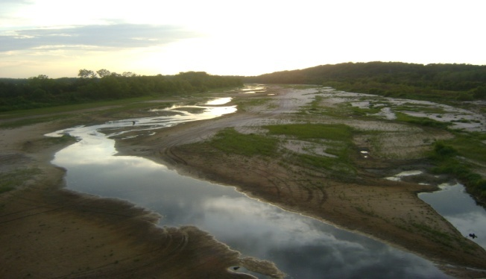
CATASTROPHIC DROUGHT HIGHLIGHTS INHERENT WEAKNESS WITHIN U.S. SYSTEM OF EMERGENCY MANAGEMENT: A NEED FOR PRESIDENTIAL ACTION

“…There is no cohesive national drought policy at the federal level, nor is there a lead agency that coordinates federal programs.” Congressional Research Service, January 22, 2010

Abstract: Droughts are the most costly form of natural disasters in many ways. They pose the greatest political, socio-economic threat to nations, and strike at the two greatest core areas of need for any population: food and water. Hence, catastrophic droughts or the threat of such droughts are a national security matter for the United States Government as the impacts of U.S. regional droughts are felt both nationally and globally. This policy paper highlights the inherent weaknesses exposed by the current catastrophic drought and concurrent extreme heat wave within the Western United States of the Federal Government’s inability to address a catastrophic regional drought. This is directly due to the lack of a national drought policy, failure to fully coordinate and utilize existing interagency emergency management statutory authorities, mechanisms, and the National Response Framework as well as the absence of catastrophic planning for this type of serious natural disaster. Further, U.S. Governors should firmly ask for Presidential action and request disaster declarations through the Department of Homeland Security/Federal Emergency Management Agency under the Robert T. Stafford Act for the President’s approval, and no longer request limited disaster declarations from the U.S. Department of Agriculture Secretary that limits U.S. Federal support to the States. These shortcomings are further exacerbated by a lack of understanding within domestic U.S. civilian agencies of the serious impacts of droughts as they are perceived as exclusively agriculture crises, though they are far beyond the scope and capabilities of agricultural programs to address by themselves. The President’s intervention is needed immediately to bring in sufficient national interagency resources to mitigate against the current threat to the U.S economy, our food supply including livestock and population, while putting into place an adequate national policy, plans and emergency programs that meet operational requirements that are not currently in place for this and future catastrophic droughts.

2011
Stephen Jimenez, M.S. and Amanda Jimenez
9/1/2011

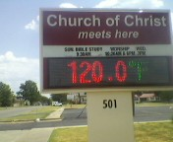
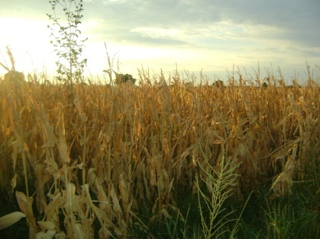
Dante's Inferno Holdenville, Oklahoma August 2011 Courtesy of Mary Ann Chronister Copyright 2011, All Rights Reserved
Total Corn Crop Failure South Central Oklahoma August 2011 Stephen Jimenez Copyright 2011, All Rights Reserved
TABLE OF CONTENTS
SUMMARY 3
CURRENT WESTERN U.S. DROUGHT OVERVIEW 5
Geographic Area 5
Severity 6
Selected State, National and Global Impacts 8
Long Term Drought Forecast 11
U.S. INTEGRATED “ALL HAZARDS” SYSTEM OF EMERGENCY MANAGEMENT 12
Historical Evolution 12
Statutory Authorities and the National Response Framework 14
Comparative Analysis: Drought Management vs. All Disasters 16
Shortcomings of the National Response Framework 21
CATASTROPHIC DROUGHTS: A NATIONAL SECURITY MATTER 22
RECOMMENDED PRESIDENTIAL ACTIONS 23
CONCLUSION 27
SELECTED BIBLIOGRAPHY 29

CATASTROPHIC DROUGHT HIGHLIGHTS INHERENT WEAKNESS WITHIN U.S. SYSTEM OF EMERGENCY MANAGEMENT: A NEED FOR PRESIDENTIAL ACTION

SUMMARY

It is our intention for this paper to create high-level awareness of the potential gravity of the current drought and heat wave crisis within the Western U.S., and of the strategic threat to the interests of the U.S. by a future larger crisis. We recognize there are many hard working and capable political appointees from both political parties and civil servants. This paper is to be construed as being constructive and not any slighted attack against Federal or State agencies or elected officials, but a serious discussion at the state and national level needs to occur and be expedited with deeds and not just words. This crisis requires Presidential action and additional coordinated efforts by Governors, U.S. Secretary of Agriculture and the Director of the Federal Emergency Management Agency (FEMA).

Droughts are the most costly form of natural disasters in many ways. They pose the greatest political, socio-economic threat to nations, and strike at the two greatest core areas of need for any population: food and water. Hence, catastrophic droughts or the threat of such droughts are a national security matter for the United States Government and the impacts of U.S. regional droughts are felt both nationally and globally. This paper highlights the inherent weaknesses exposed by the current catastrophic drought and concurrent heat wave within the Western United States of the Federal Government’s inability to address a catastrophic regional drought.

Highlighting this problem President Obama recently in a speech clearly stated he believes that FEMA is working droughts and could be construed as to believe they are the Lead Federal Agency (LFA) for droughts including this catastrophic drought:

“Government are also those FEMA folks when there’s a flood or a drought or some emergency who come out and are helping people out. That’s government.”
President Obama, August 15, 2011

The President is correct. FEMA should be involved in such severe and catastrophic droughts. Yet, FEMA is no-where to be found and as usual the U.S. Department of Agriculture is going it alone to the detriment of the nation, which is not a poor reflection on USDA. Traditionally, disasters can be addressed by individual departments under their own statutory authorities. A predominance of agricultural impacts within droughts require more than agricultural expertise and programs to address and are too dangerous to leave within the purview of a single Federal Department. We do not leave hurricanes and terrorism incidents to a single Federal Department to address, nor should we for severe and catastrophic droughts, which can threaten the core existence of a nation as has repeatedly occurred throughout history. The United States is no exception, and to think we are exempt from such catastrophes would be the greatest mistake any nation could make. The nation has a viable system of emergency management and homeland security that is scalable and flexible, which allows for partial or full involvement by any number or combination of Federal departments or agencies, which is lead by FEMA. Yet, we are not effectively using this system as this crisis highlights.

President Obama has inherited a seventy-five plus year old inadequate, inconsistent and dysfunctional system of emergency planning and responding to droughts and extreme heat waves that is in place without a coherent drought policy. This undermines the nation’s existing functional system of emergency management and threatens the United States. The current catastrophic drought within the Western U.S. has highlighted deficiencies within the national structure of emergency management planning, and legal hodge-podge of statutory authorities, which Congress knows exists. Congressional Research Service basically has it correct when they stated:

“…There is no cohesive national drought policy at the federal level, nor is there a lead agency that coordinates federal programs.” Congressional Research Service, January 22, 2010

But, they too while acknowledging droughts are disasters are not cognizant in the forefront of their thoughts and analysis that since 1979 when FEMA was created this nation set out to develop a comprehensive system of emergency management, and that droughts are “fully” recognized as natural disasters. Because droughts come on rather slow, are hard to accurately forecast as to their occurrence, duration and geographic area, and they have few sensational photograph’s of wind, water or damage from explosions like occurred during the 9-11-01 terrorist attacks at World Trade Center, the media, policy makers and some emergency managers often fail to understand the strategic threat and extent of the damage. Severe and catastrophic droughts in conjunction with extreme heat waves require skill sets and the flexibility to respond that any one department cannot address adequately by themselves. Globally, droughts are far more lethal than most other disasters. In fact, they are multi-year or decade events, unlike short term flooding or most other short duration natural or man-made disasters.

Hence, we see because of these shortcomings and misperception states going to the Secretary of Agriculture for disaster declarations instead of to the Department of Homeland Security/Federal Emergency Management Agency due to a cultural misperception within political and emergency management circles that droughts are different than all other disasters. This ultimately hinders and limits the ability of federal and state departments to plan, mitigate and respond to the current and future catastrophic droughts in a timely manner, and the flexibility to shift course to adapt to changing circumstances.
INCHES OF WATER:
REGIONS SOURCES OF WATER DRYING UP
South Canadian River, Oklahoma
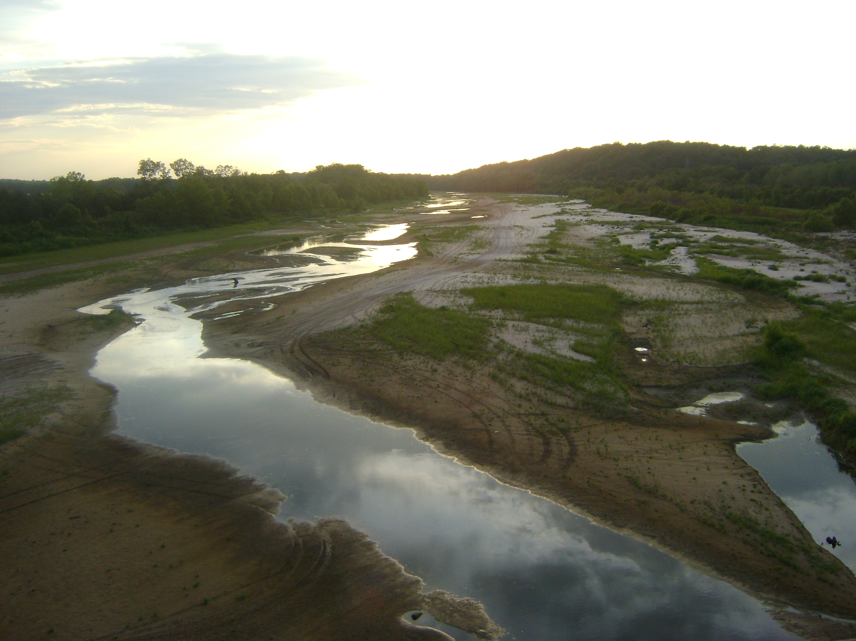
Stephen Jimenez, Copyright 2011, All Rights Reserved

In order to highlight the inadequacies of our system of policies, planning and operations for drought and possible famine in a worst case catastrophic drought think of this example. Thousands of years ago an Egyptian Pharaoh reached outside of his political appointees and appointed a seemingly ordinary man named Joseph who was reported to have integrity, exceptional planning and administration skills to prepare his nation for a future seven year drought/famine during a time of no drought. Egypt survived. Today, the U.S. would not survive as Egypt did even with all of our technology and superior resources due to a lack of foresight, coordinated policy, planning and operations.

Like the Egyptian Pharaoh, thousands of years ago, the United States needs our elected President to immediately intervene to bring in sufficient national interagency resources to mitigate against the current threat to the U.S economy, our food supply including livestock and population, while putting into place an adequate national policy, plans and emergency programs that meet operational requirements that are not currently in place for this and future catastrophic droughts.

CURRENT WESTERN U.S. DROUGHT OVERVIEW

Geographic Area
The current catastrophic drought in the Western U.S. is a quiet killer of Americans and threatens our economy, which many citizens or policy makers are not fully aware of the implications. The current drought, reflected within Chart One: Scope of the National Crisis is extensive covering virtually the entire States of Texas and Oklahoma with significant parts of New Mexico, Louisiana and Kansas. It also covers smaller areas of Colorado and other states.
This is a major geographic area of the United States with multiple major population centers as well as being a major producer of beef, pork, fruit including nuts, vegetables and other food. This significant portion of America’s heartland is a core part of the nation’s and world’s food supply. What is dangerous is that the Federal Government knows the daily growing extent and potential threats of this crisis, yet applies fewer resources than they did during Hurricane Irene and during other disasters. Other disasters in the end that will be far smaller compared to this crisis, and this crisis has a larger strategic threat to the United States.
Chart One: Scope of the National Crisis
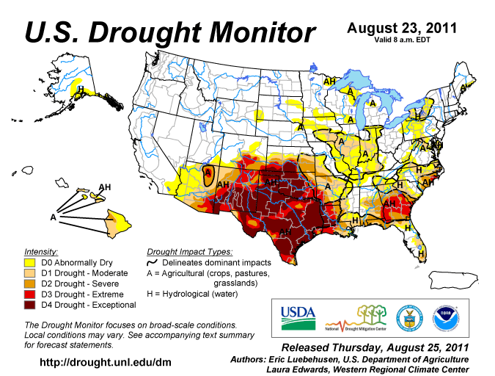

Severity

The United States Government and many states have not fully considered the exact strategic ramifications of extreme droughts, different drought scenarios or how to address them. A significant amount of work has been done by the U.S. Government to categorize drought severity as well as other thinking on the subject by the Governor’s, various Federal agencies, Congress and others. This should be fully leveraged. America and our government at all levels have some of the finest men and woman with diverse professional qualifications that are required to address this threat to the nation. An example of classification of drought severity vis. a vis. this specific crisis is shown in Chart 2: Drought Conditions within Texas.

Chart Two: Drought Conditions within Texas
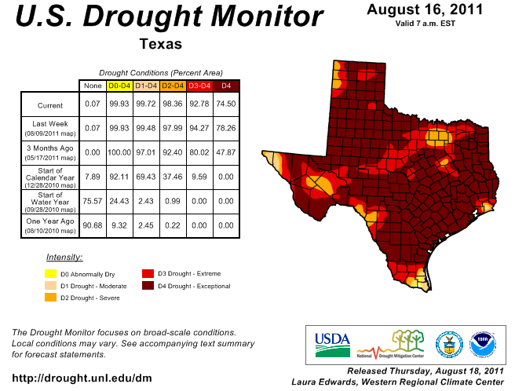
The key two aspects of this Geographic Information System (GIS) mapping product highlights a) the intensity of the drought and b) the percent of area that is categorized by intensity level as reflected in the corresponding table for the State of Texas. Overall, there are five levels of drought conditions that are D0 through D4. D4 is the worst severity.
A quick review of the color coded map and associated percentage of the State of Texas that is in each respective category of drought “clearly” reveals to any observer that 74.50% of the entire area of Texas is in the worst drought condition D4 and when combined with level D3 that climbs to 92.78% of the state in the two worst drought conditions. This information when combined with information from other states, especially New Mexico and Oklahoma, and an ongoing growing damage assessment from this disaster with no end in sight shows this is a catastrophic event that has overwhelmed the states and U.S. Department of Agriculture’s abilities to exclusively provide support to the states under their own authorities. Yet, the full capabilities of the federal government are not brought to bear in an effort to respond, mitigate and to conduct contingency planning and strategic analyses to protect America’s food supply etc.

Selected State, National and Global Impacts

Though the drought seems exclusively agricultural it is not. Droughts historically cause excessive human suffering, political, and socio-economic instability with possible national security ramifications for nations.

Drought Strikes at the Two Most Important Human Needs: Water and Food

Droughts are crises no different than a tsunami or hurricane in that elected officials and policy makers cannot wait until they see a wall of water coming at them or gale force winds with an associated storm surge to make a decision. Decisions have to been made prior to the full manifestation of the crisis. An example is how U.S. emergency managers/elected officials know a hurricane is inbound with an estimated track and intensity, but they make decisions to evacuate coastal areas, activate emergency plans, pre-position emergency teams and resources and take other actions on an interagency and intergovernmental, and international basis, as needed.

This crisis has already had such severe impacts with further catastrophic threatened impacts that if it was a tsunami, hurricane or other disaster the media, members of Congress, and others would be calling and asking more than just serious questions. There would be hearings like occurred after Hurricane Katrina. Yet, that is not occurring, not yet…

For more than a year we have not just been first-hand witnesses to the daily aspects of this crisis, but are qualified and experienced crisis and risk management professionals with emergency management and homeland security qualifications. We have watched this disaster develop without a serious and coordinated national response, nor any long-term contingency planning, while other disasters are fully declared and more than $175 million is allocated including for individual homeowner septic tanks destroyed by flooding in places like the Dakota’s. We have interviewed many Americans within the affected areas and have written the Governors of Oklahoma, Texas and the President of the United States.
Unlike other short duration disasters this crisis is ongoing with a daily growing toll. According to some estimates growing damages already include loss of human life, billions of dollars in damages, 40-90% crop losses (food) dependent upon the type of crop in affected areas, depletion of water resources, emergency reduction and elimination of a growing number of cattle herds is ongoing, and damage to infrastructure.
To put this in perspective think about these selected impacts:

- Human Life:
  - Well over 30 deaths and growing have been attributed to the drought and extreme heat wave in Texas and Oklahoma alone.
  - These numbers do not reflect human suffering from increased cost of food due to crop and livestock problems.

- Cost of the Disaster:
  - Combined costs from Texas, Oklahoma and other affected states are estimated at upwards of $8 billion and growing.
  - This is far larger than Hurricane Irene and most other disasters.

- Critical Infrastructure:
  - Numerous local jurisdictions and citizens have reported main water lines breaking due to changes in the ground from drought and extreme heat wave conditions.
  - There have been reports by citizens of roads buckling due to extreme heat wave conditions.
  - If this were a flood or ice storm Public Assistance would be provided.

- Cattle (Beef) Industry:
  - Texas and Oklahoma produces more than one out of every five pieces of beef in the nation.
  - The area of this crisis produces far more than 20% of the nation’s beef supply.
  - According to some sources mass selling “destocking” has dramatically risen, and in some cases entire herds includes young calves are being sold. This is the United States future beef supply!
  - The average weight of cattle being sold is down directly due to pasture failures.
  - Most pastures are being characterized as in very poor condition and have failed.
  - Ranchers who usually buy hay in the summer to feed the cattle in the late fall through early spring cannot find any to buy within their states.
  - Most hay found is primarily coming from many states away.
  - Hay usually purchased for winter needs is being fed during the summer to sustain America’s beef supply. There is almost no hay for the fall, winter and spring.
  - Within Oklahoma alone many that can afford to pay such prices for procurement and extreme long range shipping are saying the closest location for hay procurement is South West Missouri. Many say they are having to go farther than that for hay.
  - Further, different state restrictions on load sizes for hay in places outside the drought zone are adversely impacting America’s beef supplier’s ability to save the herds that feed every American.
  - Ranchers cannot afford to pay the increased disaster rates for hay in addition to long range mileage to ship hay. Many are getting ready to close their doors forever without direct Federal intervention!
  - USDA programs of handing out emergency money to procure hay where there is virtually no hay to procure are unrealistic, not flexible, nor meeting the national needs of the crisis.
  - This is going to cost America and the world in more than just the pocket book.

- Corn:
  - What effects the drought had were compounded by the extreme heat wave in Oklahoma and Texas, which virtually annihilated the corn crop.
  - Many informally estimate damage in excess of 90% in Oklahoma alone.
  - Corn is a staple for humans and essential for livestock animal feed products.
  - Livestock and other agricultural producers have stated that the use of corn to create ethanol fuel, which is not energy efficient, has driven up costs, taken food off the shelves of the world’s market, and in such a catastrophic crisis adversely impacts our ability to provide reasonable priced food for humans and feed for selected livestock.

- Wheat:
  - The U.S. “heartland” is one of the world’s primary breadbasket producing areas.
  - In Oklahoma alone estimates are that 40% or more of wheat crop were decimated, not factoring in others states losses.
  - Wheat is an essential agricultural product “staple” used in animal feed, and to feed many humans around the world.
  - The winter wheat crop is at risk of not being planted due to dry conditions.

- Water:
  - Sources of water essential for direct human consumption, livestock survival and other agriculture production are drying up.
  - Regional rivers, reservoirs, and watering ponds for livestock are seriously impacted.
  - Approximately 7 out of 200 reservoirs in Texas alone are no longer usable.
  - Most states water policies are not effective for such a catastrophic regional crisis.
  - The oil/gas industry relies upon local water for its drilling operations in order to provide energy for the nation. Water sources are drying up and this will impact energy costs for all Americans.

The effects of the disaster will be felt in every American’s pocket book within every neighborhood supermarket, which is obvious. This disaster is already causing political unrest with voters that may manifest itself at the election polls in 2011/2012 for both political parties due to everyday of delay in getting a Presidential Disaster Declaration and declaring this a national catastrophic disaster with a Lead Federal Agency (LFA) other than the U.S. Department of Agriculture.,,
But, it will also be felt far away from our borders. The United States helps feed the world through both the sale and donation of food that is essential in stabilizing numerous areas of the world including places like Africa where again long-term drought has affected the ability of countries to feed themselves. International organizations like the Department of Defense, intelligence agencies, and Department of State know the adverse impacts of famine caused by drought globally that directly or indirectly impact our national security. They know that America’s heartland contributes to global stability that is essential to our political, economic and national security. What occurs domestically within the United States has international ramifications that impact Americans.

Long Term Drought Forecast
Many weather and agriculture experts in the South West U.S. are saying there is no relief in sight with quite a few saying this crisis will last for at least 1-2 more years. And, that is a problem on two different levels. First, there is no accurate manner to forecast with certainty the duration and extent of any drought. Second, this drought within the little more than first year has broken many records including some going back more than a hundred years, since records were first kept in places like Texas and Oklahoma. Chart 3 shows the government’s short term forecast.
Chart 3: U.S. Government Seasonal Drought Forecast
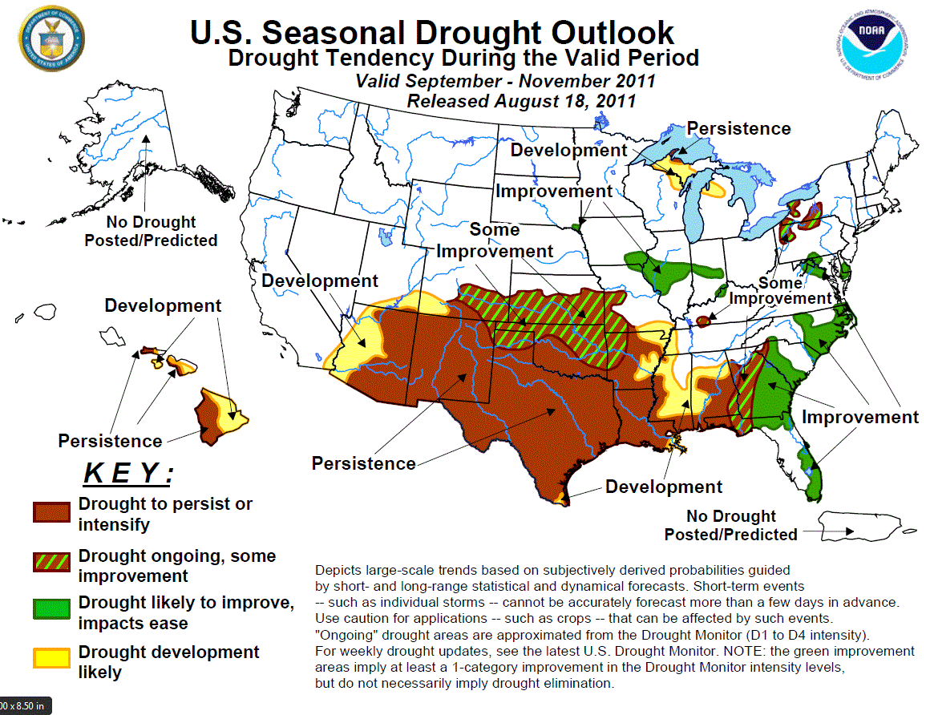
“The U.S. Climate Prediction Center said the La Nina weather pattern blamed for the lack of rain might be back soon, and if that happens, the dry spell would almost certainly extend into 2012.”

Trends indicate this is a growing drought in conjunction with a record setting deadly heat wave that is a concurrent dangerous secondary disaster and combination of natural effects, which makes this an ongoing national “catastrophic disaster.” This crisis should have at least the same national coordinated attention as a recent disaster like Hurricane Irene attained, but as of this time has not been properly addressed.

U.S. INTEGRATED “ALL HAZARDS” SYSTEM OF EMERGENCY MANAGEMENT

Historical Evolution

To understand the problem of the U.S. Federal government’s handling of drought one has to quickly understand that the U.S. system of emergency management is relatively new as is the profession of emergency management. Though modern U.S. national emergency planning started during the early years of the Cold War in response to the threat of nuclear war with a secondary track of disaster assistance to the states our modern system of emergency management really began in 1979. That was the year that the Federal Emergency Management Agency was created. FEMA was created by combining a number of Federal organizations.

Thus began the process to create a modern system of emergency management. Yet, it took until 1988 to create the Robert T. Stafford Act, which actually gave FEMA some real authority. This was followed by the development of the Federal Response Plan (FRP) in 1992 that defined roles, missions and relationships between federal departments, which occurred during a historical watershed event and the costly lessons of a Hurricane Andrew: Category V. Andrew devastated Southern Florida and went on to make landfall in the Gulf Coast states, which led to a growth and development of the “all hazards” system of emergency management.

Throughout the 1990’s the system of emergency management nationwide was solidified into a profession with dedicated local, state and Federal emergency managers with the concept of all-hazards emergency management being correctly promoted. Unfortunately at the same time, FEMA’s national security analysis, preparedness and national strategic contingency planning capabilities born from the threat of nuclear war during the Cold War were dismantled instead of being re-tooled in a misguided euphoria of the end of the Cold War, which some would rather not come to light their shortsightedness. The 90’s witnessed radiological emergencies and terrorism being incorporated into the system’s preparedness and response efforts, so that when the September 11th, 2001 terrorist attacks occurred the U.S. response to the worst global terrorist attack to date was exceptional.

In 2003, in response to the findings of the 9-11 Commission and other political pressures the Department of Homeland Security was created and absorbed FEMA and a number of other agencies. FEMA was partially dismantled and the focus as a result of war and the threat of a possible catastrophic terrorist attack resulted in the nation not being prepared for catastrophic natural disasters. In 2004, the old Federal Response Plan was replaced by the National Response Plan (NRP).

In 2005, another major watershed event occurred as Hurricane Katrina devastated the Gulf Coast with Louisiana’s near total failure at the local and state levels coupled with Federal mistakes shocked the world, Congress and the American public. This resulted in the Post Katrina Emergency Management Reform Act of 2006 that basically re-unified FEMA as an agency, clarified reporting relationships of the FEMA Director and strengthened the agency within the Department of Homeland Security.

Table 1: Selected Historical Timeline: Modern U.S. System of Emergency Management

MODERN U.S. EMERGENCY MANAGEMENT TIMELINE
1979 | FEMA Created: Executive Order 12127
1988 | Robert T. Stafford Disaster Relief and Emergency Assistance Act
1992 | Federal Response Plan
1992 | Hurricane Andrew
2001 | September 11th 2001 Terrorist Attacks
2003 | Department of Homeland Security Created
2004 | National Response Plan
2005 | Hurricane Katrina
2006 | Robert T. Stafford Act Amended
2006 | Post Katrina Emergency Management Reform Act
2008 | National Response Framework
2010-Present | Growing Catastrophic Drought Western U.S.

In 2008, the NRP was overhauled and the National Response Framework (NRF) was created and resulted in FEMA again, being strengthened and all-hazard emergency management including catastrophic planning for most natural and man-made disasters being taken seriously. Yet, severe and catastrophic drought was still not anywhere to be found within national policy, planning or operations, except for lip service at the national level.,

Statutory Authorities and the National Response Framework

While there are a plethora of statutory authorities that the Federal Government can and does utilize, especially for USDA programs the following are a select few that are critical to the U.S. system of emergency management and homeland security that are directly applicable for the Federal Government during severe or catastrophic droughts.

10th Amendment to the United States Constitution

The 10th Amendment to paraphrase basically states that all powers not expressly given to the Federal government belong to the States. The United States system of emergency management is a bottom-up system of support to the States. Local jurisdictions who have been overwhelmed request state assistance and likewise the State Governor’s request assistance from the Federal Government for most disasters when they are overwhelmed, though there are exceptions. But, what is essential for discussion of catastrophic disasters is that the Federal Government has been given by America’s Founding Fathers explicit responsibility for the defense of the nation a.k.a. national security. Severe and catastrophic droughts strike and can threaten the very existence of a nation. They should be taken very seriously as a national security matter in a proactive manner.

Robert T. Stafford Disaster Relief and Emergency Assistance Act (Stafford Act)

“Authorizes the programs and processes by which the Federal Government provides disaster and emergency assistance to State, Tribal, and local governments, eligible private nonprofit organizations, and individuals affected by a declared major disaster or emergency. The Stafford
Act covers all hazards, including natural disasters and terrorist events. It also encourages hazard mitigation measures to reduce losses from disasters establishing programs for State, Tribal, and local hazard mitigation planning, as well as grant programs that provide funding mechanisms to reduce losses in pre- and post-disaster environments.”

Post Katrina Emergency Management Reform Act of 2006 (PKEMRA)

“Clarified and modified the Homeland Security Act with respect to the organizational structure, authorities, and responsibilities of FEMA and the FEMA Administrator. It enhanced FEMA’s responsibilities and its authority within DHS and transferred many functions of DHS’s former Preparedness Directorate to FEMA. According to PKEMRA, FEMA leads and supports the Nation in a risk-based, comprehensive emergency management system of preparedness, protection, response, recovery, and mitigation. Under the act, the FEMA Administrator reports directly to the Secretary of Homeland Security, and FEMA is a distinct entity within DHS.”

National Response Framework

“Is a guide to how the Nation conducts all-hazards response. It is built upon scalable, flexible, and adaptable coordinating structures to align key roles and responsibilities across the Nation, linking all levels of government, nongovernment organizations, and the private sector. It is intended to capture specific authorities and best practices for managing incidents that range from serious but purely local events to large-scale terrorist attacks or catastrophic natural disasters.”

Homeland Security Presidential Directive (HSPD)-5: Incident Management

“Directs the establishment of a single, comprehensive national incident management system led by the Secretary of Homeland Security that covers the prevention, preparation, support, response, and recovery from terrorist attacks, major disasters, and other emergencies. The implementation of such a system includes plans, doctrine, resource typing credentialing, team and cadre formation, and other activities to enable all levels of government throughout the Nation to work together efficiently and effectively.”

PPD-8: National Preparedness

PPD-8 states “This directive is aimed at strengthening the security and resilience of the United States through systematic preparation for the threats that pose the greatest risk to the security of the Nation, including acts of terrorism, cyber attacks, pandemics, and catastrophic natural disasters. Our national preparedness is the shared responsibility of all levels of government, the private and nonprofit sectors, and individual citizens.”

It goes on to state:

“Nothing in this directive is intended to alter or impede the ability to carry out the authorities of executive departments and agencies to perform their responsibilities under law and consistent with applicable legal authorities and other Presidential guidance. This directive shall be implemented consistent with relevant authorities, including the Post-Katrina Emergency Management Reform Act of 2006 and its assignment of responsibilities with respect to the Administrator of the Federal Emergency Management Agency.”

And,

“This directive replaces Homeland Security Presidential Directive (HSPD)-8 (National Preparedness), issued December 17, 2003, and HSPD-8 Annex I (National Planning), issued December 4, 2007, which are hereby rescinded, except for paragraph 44 of HSPD-8 Annex I. Individual plans developed under HSPD-8 and Annex I remain in effect until rescinded or otherwise replaced.”

Homeland Security Presidential Directive 9: Defense of United States Agriculture and Food
“Homeland Security Presidential Directive (HSPD) 9 establishes a national policy to defend the agriculture and food system against terrorist attacks, major disasters, and other emergencies. America's agriculture and food system is an extensive, open, interconnected, diverse, and complex structure providing potential targets for terrorist attacks. U.S. agriculture and food systems are vulnerable to disease, pest, or poisonous agents that occur naturally, are unintentionally introduced, or are intentionally delivered by acts of terrorism. The directive lays out policies, including roles and responsibilities, awareness and warning, and vulnerability assessments, to provide the best protection possible against a successful attack on the U.S. agriculture and food system.”

Overall, the Federal government has sufficient statutory authorities and interagency capabilities including Presidential direction sufficient to initiate a coordinated response to severe and catastrophic droughts, while other policy and planning efforts are initiated. States do not have sufficient resources and capabilities to address severe or catastrophic droughts.

Comparative Analysis: Drought Management vs. All Disasters

When the President, Congress and Americans including many in the media think of the current drought in the Western United States, a hurricane like Katrina or Irene that just occurred, the September 11^{th,} 2001 terrorist attacks, or other natural or man-made crises they believe the U.S. Government has a policy, a plan and that the Federal Emergency Management Agency is the Lead Federal Agency. After all, FEMA is by its name is the Agency that Manages Emergencies at the Federal level, or does it? We agree it does, but unfortunately that is not the perception by some in government to the nation’s peril. Yet, the reality of the situation is the Department of Homeland Security (DHS)/FEMA is not involved and seldom is involved in most droughts.

Since 1979 with few exceptions FEMA has been absent from most droughts and mostly intervenes in droughts in overseas U.S. Territories. There are many emergency managers that do not see past the direct agricultural impacts and even some FEMA civil servants are concerned about duplicative efforts, which are not a problem, if we as a nation follow our sound system of emergency management with coordinated interagency planning and operations using the Emergency Support Functions (ESF) of the National Response Framework (NRF). See Table 2.

The U.S. has in place a “comprehensive” system of emergency management that is based off of numerous statutory authorities and mechanisms including the Robert T. Stafford Act and the NRF. Further, the U.S Federal Government has preeminent jurisdiction for national security. Legislation clearly states disasters include droughts in addition to other types of hazards. If this was a Hurricanes Katrina, Rita, 9-11-01 type terrorist attack or another “regional disaster” the President would have been given a major disaster declaration or emergency declaration to sign. The Department of Homeland Security/Federal Emergency Management Agency (FEMA) would have implemented the Stafford Act and National Response Framework (NRF), calling this a catastrophic disaster, which under that authority all Federal Departments and Agencies could be tasked on a reimbursable or non-reimbursable basis as is done for all disasters requiring Federal assistance.
Instead, there is an incorrect psychological belief not based in our laws, policies or plans that there is no Lead Federal Agency (LFA) for droughts. That is incorrect. It is implied within the previous mentioned authorities and definitions cited within this paper. Even within the NRF the definition of a drought, which is a recognized disaster implies the need for its use and interagency involvement, which states:
“A catastrophic incident is defined as any natural or manmade incident, including terrorism, that results in extraordinary levels of mass casualties, damage, or disruption severely affecting the population, infrastructure, environment, economy, national morale, and/or government functions.” NRF

What is occurring nationally is like in 1992 when Hurricane Andrew bore down on Southern Florida, and the Legislative and Executive Branches and all their staff’s and attorney’s believed, erroneously that the Stafford Act “did not” allow for the pre-positioning of Federal resources and personnel in the face of an imminent disaster. The result was Florida was not only devastated, but there was a poor Federal response. Yet, in less than 72 hours, the Federal Government woke up, while Hurricane Andrew was in the Gulf of Mexico bearing down on the Gulf Coast States and the interpretation of the Stafford Act was forever changed. Federal resources and personnel to this date are pre-positioned!
We have the same problems with droughts today. They are disasters that require integrated and coordinated Federal policy, planning and response operations. We have many of the pieces needed for drought policy development, catastrophic planning and response operations. We just need to connect our dots as a nation and utilize what we already have in place and build upon it.
Governors should direct their staff and associated state emergency management, and agriculture agencies to ask through the Department of Homeland Security/Federal Emergency Management Agency (FEMA) for the President to declare a major disaster declaration for severe or catastrophic droughts (D3/D4). This needs to occur early in the crisis to meet immediate and long-term needs of the drought that cover several states.
Further, they need to re-emphasize their support for the President to clearly re-affirm that FEMA is the LFA for Federal disaster direction and coordination and that includes severe and catastrophic droughts. Severe and catastrophic droughts are disasters requiring interagency resources.

Table 2: National Response Framework, Emergency Support Functions
NATIONAL RESPONSE FRAMEWORK (NRF)
EMERGENCY SUPPORT FUNCTIONS (ESF)
ESF | Primary Agency or Agencies
ESF#1 Transportation | Department of Transportation
ESF#2 Communications | Department of Homeland Security (DHS)/National Protection and Programs/Cyber security and Communications/National Communications System  Department of Homeland Security (DHS)/Federal Emergency Management Agency (FEMA)
ESF#3 Public Works and Engineering | Department of Defense (DOD)/U.S. Army Corps of Engineers  Department of Homeland Security (DHS)/Federal Emergency Management Agency (FEMA)
ESF#4 Firefighting | Department of Agriculture/Forest Service
ESF#5 Emergency Management | Department of Homeland Security (DHS)/Federal Emergency Management Agency (FEMA)
ESF#6 Mass Care, Emergency Assistance, Housing, and Human Services | Department of Homeland Security (DHS)/Federal Emergency Management Agency (FEMA)
ESF#7 Logistics Management and Resource Support | General Services Administration (GSA)  Department of Homeland Security (DHS)/Federal Emergency Management Agency (FEMA)
ESF#8 Public Health and Medical Services | Department of Health and Human Services (HHS)
ESF#9 Search and Rescue | Department of Homeland Security (DHS)/ Federal Emergency Management Agency (FEMA)  Department of Homeland Security (DHS)/U.S. Coast Guard (USCG)  Department of the Interior (DOI)/National Park Service (NPS)  Department of Defense (DOD)
ESF#10 Oil and Hazardous Materials Response | Environmental Protection Agency (EPA) Department of Homeland Security (DHS)/U.S. Coast Guard (USCG)
ESF#11 Agriculture and Natural Resources | Department of Agriculture (USDA)  Department of the Interior (DOI)
ESF#12 Energy | Department of Energy (DOE)
ESF#13 Public Safety and Security | Department of Justice (DOJ)
ESF#14 Long-Term Community Recovery | Department of Agriculture (USDA)  Department of Homeland Security (DHS)  Department of Housing and Urban Development (HUD)  Small Business Administration (SBA)
ESF#15 External Affairs | Department of Homeland Security/FEMA
The National Response Framework clearly lays out these ESF’s, which are not new to anyone at the Federal or State levels, which states:

ESF #1 – Transportation

“Transportation provides support to the Department of Homeland Security (DHS) by assisting Federal, State, tribal and local governmental entities, voluntary organizations, nongovernmental organizations, and the private sector in the management of transportation systems and infrastructure during domestic threats or in response to incidents. ESF #1 also participates in prevention, preparedness, response, recovery, and mitigation activities. ESF #1 carries out the Department of Transportation (DOT)’s statutory responsibilities, including regulation of transportation, management of the Nation’s airspace, and ensuring the safety and security of the national transportation system.”

ESF #2 – Communications

“Emergency Support Function (ESF) #2 – Communications supports the restoration of the communications infrastructure, facilitates the recovery of systems and applications from cyber attacks, and coordinates Federal communications support to response efforts during incidents requiring a coordinated Federal response. This ESF implements the provisions of the Office of Science and Technology Policy (OSTP) National Plan for Telecommunications Support in Non-Wartime Emergencies (NPTS).”

ESF #3 - Public Works and Engineering

“Emergency Support Function (ESF) #3 – Public Works and Engineering assists the Department of Homeland Security (DHS) by coordinating and organizing the capabilities and resources of the Federal Government to facilitate the delivery of services, technical assistance, engineering expertise, construction management, and other support to prepare for, respond to, and/or recover from a disaster or an incident requiring a coordinated Federal response.”

ESF #4 – Firefighting

“Emergency Support Function (ESF) #4 – Firefighting provides Federal support for the detection and suppression of wild land, rural, and urban fires resulting from, or occurring coincidentally with an incident requiring a coordinated Federal response for assistance.”

ESF #5 - Emergency Management

“Emergency Support Function (ESF) #5 – Emergency Management is responsible for supporting overall activities of the Federal Government for domestic incident management. ESF #5 provides the core management and administrative functions in support of National Response Coordination Center (NRCC), Regional Response Coordination Center (RRCC), and Joint Field Office (JFO) operations.”

ESF #6 - Mass Care, Emergency Assistance, Housing, and Human Services

“Emergency Support Function (ESF) #6 – Mass Care, Emergency Assistance, Housing, and Human Services coordinates the delivery of Federal mass care, emergency assistance, housing, and human services when local, tribal, and State response and recovery needs exceed their capabilities.”

ESF #7 - Logistics Management and Resource Support

“Emergency Support Function (ESF) #7 – Logistics Management and Resource Support assists the Department of Homeland Security (DHS) in providing a comprehensive, national disaster logistics planning, management, and sustainment capability that harnesses the resources of Federal logistics partners, key public and private stakeholders, and nongovernmental organizations (NGOs) to meet the needs of disaster victims and responders.”

ESF #8 - Public Health and Medical Services

“Emergency Support Function (ESF) #8 – Public Health and Medical Services provides the mechanism for coordinated Federal assistance to supplement State, tribal, and local resources in response to a public health and medical disaster, potential or actual incidents requiring a coordinated Federal response, and/or during a developing potential health and medical emergency. Public Health and Medical Services include responding to medical needs associated with mental health, behavioral health, and substance abuse considerations of incident victims and response workers. Services also cover the medical needs of members of the “at risk” or “special needs” population described in the Pandemic and All-Hazards Preparedness Act and in the National Response Framework (NRF) Glossary, respectively. It includes a population whose members may have medical and other functional needs before, during, and after an incident.”

ESF #9 - Search and Rescue

“Emergency Support Function (ESF) #9 – Search and Rescue rapidly deploys components of the Federal Search and Rescue (SAR) Response System to provide specialized lifesaving assistance to State, tribal, and local authorities when activated for incidents or potential incidents requiring a coordinated Federal response.”

ESF #10 - Oil and Hazardous Materials Response

“Emergency Support Function (ESF) #10 – Oil and Hazardous Materials Response provides Federal support in response to an actual or potential discharge and/or uncontrolled release of oil or hazardous materials when activated. ESF #10 provides for a coordinated Federal response to actual or potential oil and hazardous materials incidents.”

ESF #11 - Agriculture and Natural Resources

“Emergency Support Function (ESF) #11 – Agriculture and Natural Resources supports State, tribal and local authorities and other Federal agency efforts to:
- Provide nutrition assistance.
- Control and eradicate, as appropriate, any outbreak of a highly contagious or economically devastating animal/zoonotic (i.e., transmitted between animals and people) disease or any outbreak of an economically devastating plant pest or disease.
- Ensure the safety and security of the commercial food supply.
- Protect natural and cultural resources and historic properties (NCH) resources.
- Provide for the safety and well-being of household pets during an emergency response or evacuation situation.”

ESF #12 – Energy

“Emergency Support Function (ESF) #12 – Energy is intended to facilitate the restoration of damaged energy systems and components when activated by the Secretary of Homeland Security for incidents requiring a coordinated Federal response. Under Department of Energy (DOE) leadership, ESF #12 is an integral part of the larger DOE responsibility of maintaining continuous and reliable energy supplies for the United States through preventive measures and restoration and recovery actions.”

ESF #13 - Public Safety and Security

“Emergency Support Function (ESF) #13 – Public Safety and Security integrates Federal public safety and security capabilities and resources to support the full range of incident management activities associated with potential or actual incidents requiring a coordinated Federal response.”

ESF #14 - Long-Term Community Recovery

“Emergency Support Function (ESF) #14 – Long-Term Community Recovery provides a mechanism for coordinating Federal support to State, tribal, regional, and local governments, nongovernmental organizations (NGOs), and the private sector to enable community recovery from the long-term consequences of extraordinary disasters.”

ESF #15 - External Affairs

“Emergency Support Function (ESF) #15 – External Affairs ensures that sufficient Federal assets are deployed to the field during incidents requiring a coordinated Federal response to provide accurate, coordinated, timely and accessible information to affected audiences, including governments, media, the private sector, and the local populace, including the special needs population.”

Shortcomings of the National Response Framework

The Secretary of Homeland Security should have the authority to declare an Incident of National Significance (INS) of at least clearly demarcate for the States and the Federal interagency community when a catastrophic disaster has occurred or is threatened. This would not be in conflict with the NRF being scalable and flexible.

Under the previous NRP there were Incidents of National Significant. But, under the NRF there were political sensitivities with the term that resulted in such terminology be stricken that stated:

“A Federal department or agency acting on independent authority may be the initial and the primary Federal responder, but incidents that require more systematic Federal response efforts are now actively coordinated through the appropriate Framework mechanisms described in this document and in its supporting annexes. This initial coordination of Federal incident assessment and response efforts is intended to occur seamlessly, without the need for any formal trigger mechanism. This Framework, therefore, eliminates the Incident of National Significance declaration. No such declaration is required by the Framework and none will be made. The authorities of the Secretary of Homeland Security to coordinate large-scale national responses are unaltered by this change. Elimination of this declaration will, however, support a more nimble, scalable, and coordinated response by the entire national emergency management community.”
We partially disagree with the verbiage within the National Response Framework as this catastrophic drought highlights the inability to orient the States and Federal emergency personnel at all levels to the fact there is a catastrophic event ongoing. We are not saying we agree with the previous definition of the INS, but there needs to be a clear threshold demarcation for such catastrophic events. Clear triggers and thresholds should be identified and discussed in a national policy context for possible amendment of the NRF and in development of a national drought policy.

While there is room for improvement in the NRF it is a viable mechanism. We have only one Federal Emergency Management Agency with a national Emergency Support Function (ESF) structure that other Federal departments and agencies are a part of the NRF that should be utilized fully. USDA or any department going it alone is a recipe for national failure.

CATASTROPHIC DROUGHTS: A NATIONAL SECURITY MATTER

Droughts are disasters as stated within the Robert T. Stafford Act that are not exclusively agricultural in nature, and even the agricultural aspects have non-agricultural impacts. The nation’s ability to feed itself and access to drinking water is a national security matter, as it strikes at our population’s core ability to survive, be productive and ultimately from a political, socio-economic stability perspective. America’s Founding Fathers gave the Federal government explicit jurisdiction over national security. While, our emergency management system is a bottom-up system governed by the 10th Amendment to the U.S. Constitution with the States having preeminent jurisdiction, national security is a Federal responsibility.

This or a future larger crisis is too significant or large for an individual federal agency to address exclusively by themselves, which is why we have a Department of Homeland Security that is the LFA for the National Response Framework. For Hurricane’s Katrina and Rita, the Secretary of Homeland Security assumed the leadership role triggered by the law to manage the crisis under the NRF’s predecessor the NRP and for Rita declared it (prior to it making landfall) an Incident of National Significance. Now, while hurricanes and other disasters can have catastrophic consequences, a catastrophic drought for a nation can have far more disastrous consequences and should not be taken lightly.

The Federal government needs to stop spending time, personnel, resources and hundreds of millions of federal funds to augment states budgets on smaller and mid-size disasters that the States should be exclusively handling and focus on the larger threats, which include catastrophic disasters. If there is a shortage of funding and resources the Federal government instead of giving money to citizens to fix individual homeowner septic tanks after a flood needs to be protecting things like the food supply of our entire population, human lives from lack of food and water as well as our infrastructure.

As a nation we need to step back and realize we only have limited personnel, time, resources and money, and while all disasters are tragic and important to disaster victims the national government is not responsible for every disaster that threatens the States. States need to right size. The Federal government should focus on the larger disasters that have regional, national or global impacts on our security as well as those that truly overwhelm the States.

States that cannot manage their budgets, right size their government staffing in accordance with a realistic tax base a.k.a. live within their means are the problem that is draining precious U.S. tax dollars and limited emergency personnel and resources away from truly larger more threatening disasters such as catastrophic droughts. FEMA and the Federal Government as a whole needs to partially step away from the 1990’s approach of supporting many disasters that led to mission creep and involvement in many disasters that the States should be handling.

RECOMMENDED PRESIDENTIAL ACTIONS

President Obama recently stated in a speech:

“Now, too much government -- if it’s oppressive and bureaucratic and it’s not listening to people and it’s not responsive to the needs of people and isn’t customer friendly -- that’s a problem. And if you stand in line at some government office and nobody seems to be paying any attention to you, well, that needs to be fixed.” President Obama, August 15, 2011,

President Obama did not create the problem of a lack of a national drought policy or the failure to fully put in place emergency planning for drought, nor the failure to clearly re-affirm that severe and catastrophic drought operations squarely within FEMA’s leadership as is the case with most other disasters whereby they direct and coordinate national efforts as part of our national system of emergency management. But, the President has a catastrophic drought that is growing, and is in serious need of addressing. Only, the President can fully and quickly place the “train back on track” so to speak.

In July of 2011, we wrote a quick initial “no frills” paper titled “Drought in the Heartland: Threatens U.S. Economic Recovery and Food Supply” to create awareness at the state and national levels with initial immediate and long-term recommendations to get the process started. Since then we have taken our ten point plan and used that as a basis to conduct further analysis that should have been conducted at the Federal level or by selected policy analysts for the State Governors of Texas, Oklahoma and other states, who get paid and have more resources then we do, which if followed they would have arrived at the following core recommendations at a minimum.

- Appointment of a National Drought and Food Security Czar

- The National Drought and Food Security Czar needs to quickly pull together the disparate interagency efforts, primarily under USDA for this catastrophic drought as an initial priority.
- His initial four priorities should be:
- Work with USDA, FEMA, DOD, DOT, the States and private sector to protect America’s livestock through emergency creation and implementation of a National Emergency Livestock Hay/Feed Program.
- Creation of a National Drought Policy.
- Ensuring severe and catastrophic drought declarations are only Presidential.
- Draft an Executive Order clearly designating DHS/FEMA as the LFA for droughts, and re-affirming the Robert T. Stafford Act and NRF’s role in all-hazards that includes droughts and extreme heat waves.
- Food security needs to involve monitoring and ensuring the future availability in sufficient quantities of food to meet the population’s needs with a specific emphasis during natural or man-made crises including droughts and conflicts.

- Creation and Implementation of a National Emergency Livestock Hay/Feed Program

- The Secretary of Defense through U.S. Northern Command and the Secretary of Homeland Security through the Federal Emergency Management Agency with the Federal interagency community need to conduct response operations to immediately bring hay/feed to the affected disaster areas to protect America’s livestock supply, in an effort to minimize skyrocketing food costs and further economic damage.
- DOD assistance should focus more on providing logistics and contingency operations planning assistance.
- This is to be in conjunction with an interagency FEMA led effort to provide limited Individual Assistance and Public Assistance in conjunction with initiating the process for long-term strategic national contingency planning for this and any future catastrophic drought.
- The use of rail to move hay throughout the nation to specific states for further distribution by trucks needs to be assessed.
- Existing USDA programs in this area are failing.

- Development of National Drought Policy

- This is a national priority. The nation has for well over 200 years been without a comprehensive and effective national policy on drought.
- We have numerous emergency programs and operations ongoing in a poorly coordinated and thought out manner, a number of which are not working in the face of an ongoing growing catastrophic drought without such a policy or strategy in place.
- This needs to be accomplished on an expedited basis within 30 days of the Drought Czar being appointed with all members of President’s Cabinet being held accountable for its completion as a national priority.
- This is a national security matter.

- Designation of a Lead Federal Agency (LFA) for Drought: DHS/FEMA

- Clearly establishing an LFA for droughts is required.
- FEMA is America’s Agency that Manages Emergencies at the Federal level, hence the term FEMA.
- FEMA has the statutory authority, expertise and ability to direct and coordinate Federal operations involving the entire interagency community, as required, in a scalable and flexible manner.

- Initiation of Emergency Management Catastrophic Drought Planning

- This needs to be scenario based.
- Involve real actionable plans and not just Memorandum of Understanding (MOU) and other non-executable documents as currently being developed in other areas.
- U.S. DOD model for Concept of Operations (CONPLAN) and Operational Plans (OPLAN) should be adopted.
- U.S. DOD model for Defense Planning Guidance (DPG) should be tailored for civil domestic requirements for all catastrophic planning including drought.
- Deliberate and contingency planning should be initiated for best, base and worst case scenarios for catastrophic drought in different regional based scenarios to conduct analyses of the risk, scope and impacts of potential crises.
- U.S. DOD future studies and analyses (theater campaign analysts and planners) in conjunction with FEMA and civil interagency catastrophic emergency management planners, and USDA experts with expertise in food and futures analysis should work collaboratively on this effort in an expedited manner. They need to look well beyond direct agricultural and emergency management impacts on the nation.

- Development of a Clear Disaster Declaration Policy for Catastrophic Droughts

- The President needs to issue a short and clear policy reminding the departments and agencies that droughts are natural disasters and that Emergency Declarations or Major Disaster Declarations are to be under the Robert T. Stafford, and go to him for approval for all D3, D4 or other potentially threatening catastrophic droughts and heat waves.
- The Federal Government already has a process used for all other natural and man-made disasters. We do not need to re-invent the wheel.
- The President has the authority to:
- Issue a “major disaster declaration.” The Stafford Act states an “emergency” is “any occasion or instance for which, in the determination of the President, federal assistance is needed to supplement state and local efforts and capabilities to save lives……, or to lessen or avert the threat of a catastrophe in any part of the United States.” 42 U.S.C. 5122(1).
- “The President may exercise any authority vested in him by… this title with respect to an emergency when he determines that an emergency exists for which the primary responsibility for response rests with the United States because the emergency involves a subject area for which, under the Constitution or laws of the United States, the United States exercises exclusive or preeminent responsibility and authority. In determining whether or not such an emergency exists, the President shall consult the Governor of any affected state, if practicable.” 42 U.S.C. 5191(b).

- Development of a Strategic National Food Stockpile

- The USDA has an existing Food Commodity Program under 42 U.S.C. § 5180: Food Commodities, which needs to be enhanced and transitioned into a strategic national capability for catastrophic disasters and crises of national scope.
- The U.S. has a strategic fuel, pharmaceutical and other stockpiles, but not for the most important area: food.
- Food is presently available through USDA in limited amounts for disasters. If the scope of a disaster creates a need for food relief in excess of what can be provided by existing inventories, Food and Nutrition Service, FNS Headquarters works with FNS Regional Offices and State agencies to authorize emergency purchases of commodities and ships them into affected areas in a timely manner. This program was meant to feed disaster victims for a limited duration not larger catastrophic regional requirements and meet national needs during times of potential widespread food shortages that could occur.
- The Federal government should review the possibility of encouraging on at least a temporary basis crop diversification in states outside of the affected areas during such crises as part of this effort.

- Bottom-Up Review of USDA and FEMA Emergency Assistance Programs is Required

- A tertiary review of some emergency programs in this crisis clearly shows their inability to adapt to meet changing requirements of the crisis highlights the need for this to occur.
- Further, the U.S. Federal Government has increasingly national debt and deficit issues and associated budgetary issues that should mandate a careful review and re-focus to these programs as required.
- As authors we took this original recommendation from our initial baseline ten point plan and arrived at some of the recommendations contained within this paper.
- The President and Congress should require all civil departments to initiate similar efforts in accordance with the Quadrennial Defense Review (QDR) used by the Department of Defense. This would ensure policy, procurement, programs and issues are identified and programs meet national requirements and not their own needs of self-perpetuation.

- Improving Public Drought Outreach Efforts:

- Crisis communication components of USDA public outreach efforts need improvement.
- Many small businesses including ranchers and farmers are a significant component of America’s economy. They are an aging population with many not using social media, living in remote areas, and they are not receiving such information.
- USDA program personnel, many who do not have emergency management backgrounds, are running emergency agriculture programs need to get out of their offices, while leveraging in a coordinated manner FEMA’s community outreach and public affairs capabilities to get assistance where it is needed in a timely manner, while collecting relevant information on conditions in the field and effectiveness of existing federal programs given specific crises.

CONCLUSION

The catastrophic drought in the Western U.S. clearly demonstrates inherent serious weaknesses in our failure to use existing authorities and mechanisms of our national system of emergency management. FEMA for the most part is totally out of the picture with selected other Federal Agencies knowledge, skills and experience to America’s peril. Presently, Federal disaster declarations under USDA authorities are insufficient to meet the needs of this catastrophic disaster. USDA and the States capabilities by themselves are inadequate to address the immediate and possible future strategic national security threat of regional severe and catastrophic disasters.

State Governors with the Governors of Oklahoma and Texas leading should request that the recommendations for Presidential action contained within this paper take place, and they should request Presidential Disaster Declarations through DHS/FEMA. They should particularly emphasize and push for an immediate Federal hay lift into Oklahoma, Texas and other states that was an original point within the ten point plan of our short quick paper Drought in the Heartland: Threatens U.S. Economic Recovery and Food Supply. The situation has worsened and based upon numerous interviews, research and informal discussions throughout the region the situation requires such an operation become an immediate necessity.

Decisive action by the President is needed to clarify and energize the national government for this and future catastrophic droughts. The Egyptian Pharaoh had the wisdom thousands of years ago to appoint outside of his government a person to pull together his nation’s preparedness for drought-famine and lead it through the crisis years. We hope the President will actually receive this report and will have the same wisdom of leadership.

Stephen Jimenez is a Senior Consultant and a Senior Vice President for corporate operations, crisis and risk management. Previously he has been employed in either civil service or contract support positions to the Federal Emergency Management Agency National Headquarters, Defense Department, and Coalition Provisional Authority. He has served during dozens of major disasters, special events, and crises. He has worked with 27 U.S. Federal Agencies and Departments, 50 nations and all 50 states on policy, preparedness or response efforts as an emergency manager and Senior Analyst for Operations Other Than Major War. He is a recipient of the Purple Heart and FEMA Director’s Award.
Amanda Jimenez is a Senior International Crisis and Risk Management Consultant. Previously, she has worked for the U.S. Department’s of Defense, Homeland Security/Federal Emergency Management Agency (FEMA) and Agriculture in both government and consulting positions as well as the American Red Cross National Headquarters Disaster Services within their Damage Assessment Function. She has worked with more than 27 Federal Departments and Agencies and all fifty states on various disaster related response operations and preparedness efforts, and has served during more than 50 national level disasters.

SELECTED BIBLIOGRAPHY

Associated Press. Texas’ Blistering Drought Brings Forecast for Record $5.2 Billion in Crop, Livestock Losses. Lubbock, TX, August 2011.
Bea, Keith. Federal Stafford Act Disaster Assistance: Presidential Declarations, Eligible Activities and Funding. Government, Washington D.C.: Congressional Research Service, March 16, 2010.
BMcPherson. Texas Drought and Heatwave Continue to Slam Texas. Houston, Texas, August 29, 2011.
Brown, Tanya, interview by Stephen Jimenez. Writer/Editor, USDA Office of External Affairs, Farm Service Agency (August 2011).
David Schechter, WFAA. Heat, Drought Blamed for Grapevine Fish Kill. August 31, 2011. www.wfaa.com (accessed August 31, 2011).
Director of Public Affairs, Governor of Oklahoma's Office. Discussion of Drought. Oklahoma City, Oklahoma, July 2011.
Farm Aid. Wisconsin Family Farmers, Music Industry and Farm Aid Band Together to Help Drought-Stricken Oklahoma Farmers. Cambridge, MA, August 25, 2011.
Federal Emergency Management Agency - Release Number: 1981-039. Disaster Aid to North Dakotans Tops $175 Million. August 5, 2011. (accessed August 10, 2011).
Federal Emergency Management Agency. FEMA Pub 1. Government, Washington D.C.: FEMA, 2010.
Federal Emergency Management Agency Release Number: 1981-035. "Federal Assistance May Be Available When Septic Systems Fail." FEMA. Ausgust 2, 2011. www.fema.gov (accessed August 10, 2011).
Federal Emergency Management Agency. Texas Disaster History. August 2011. www.fema.gov (accessed August 2011).
FEMA. President Declares Emergency Federal Aid for The Federated States Of Micronesia. July 31, 2007. www.fema.gov (accessed August 2011).
Flakus, Greg. Experts Say World Will Feel Record Texas Drought. August 29, 2011. www.voanews.com (accessed August 29, 2011).
IRIN, The Humanitarian News and Analysis Service of the UN Office for the Coordination of Humanitarian Affairs. GLOBAL: National Drought Policies Wanted. Johannesburg, South Africa, May 11, 2011.
Ivana Kvesic, The Christian Post. Drought Costs Texas Billions, Consumers Face Higher Beef Prices. Texas, August 5, 2011.
Julie Cart and Hailey Branson-Potts Los Angeles Times. U.S. Extreme Weather May Be The New Norm. August 27, 2011. www.tennessean.com (accessed August 30, 2011).
Karen R. Krub, Jill E. Krueger, Jennifer A. Jambor Farmers’ Legal Action Group, Inc. Farmers’ Guide to Disaster Assistance. Saint Paul, Minnesota, June 2008.
Kenny, Charles. Foreign Policy: Cloudy with a Chance of Insurgency. Washington D.C.: NPR, August 31, 2011.
KLTV. "Drought Costs Texas Billions, Consumers Face Higher Beef Prices." KLTV. August 2011. www.kltv.com (accessed August 2011).
KTUL. Heat Wave's Death Toll Reaches 15 in Oklahoma. Oklahoma City, OK, August 5, 2011.
Los Angeles Times. California Drought Drove Up Energy Costs. Los Angeles, CA, June 16, 2011.
Mary Hightower, University of Arkansas Division of Agriculture. Arkansas: Relief in Forecast but Drought Damage Already Done. August 10, 2011. www.agfax.com (accessed August 20, 2011).
Matt Herrick USDA Office of Communications. Drought Policy. Washington D.C., September 1, 2011.
MF Monitor. US 2011 Losses from Natural Disasters So Far Stand at $55 Billion. MF Monitor, August 30, 2011.
National Cattlemen's Beef Association. Drought Pushes Cattle Inventory Down. August 25, 2011.
National Response Framework. Government, Washintgon D.C.: U.S. Department of Homeland Security, January 2008.
Obama, President. Remarks by the President in a Town Hall Meeting in Cannon Falls, Minnesota. Hannah’s Bend Park, Cannon Falls, Minnesota: The White House Office of the Press Secretary, August 15, 2011.
Painter, Bryan. Wednesday Marks The End of The Hottest Climatological Summer on Record For Oklahoma. Oklahoma, August 31, 2011.
Peter Folger, Betsy A. Cody and Nicole T. Carter. Drought in the United States: Causes and Issues for Congress. Government, Washington D.C.: Congressional Research Service, January 22, 2010.
President of the United States. Homeland Security Presidential Directive 5: Management of Domestic Incidents. Government, Washington D.C.: Department of Homeland Security, 2011.
President of the United States. Homeland Security Presidential Directive 9: Defense of United States Agriculture and Food. Government, Washington D.C.: Department of Homeland Security, 2004.
President of the United States. Presidential Policy Directive/PPD-8: National Preparedness. Government, Washington D.C.: Department of Homeland Security, 2011.
Ramit Plushnick-Masti-Associated Press (Published in Homeland Security Today). Texas Drought Will Harm Wildlife Habitat for Years. Canadian, Texas, August 12, 2011.
USDA Food and Nutrition Service. Disaster Manual. Government, Washington D.C.: USDA, 2004 (Updated September 2005).
The Earth Observatory, EOS Project Science Office, NASA Goddard Space Flight Center. Drought: The Creeping Disaster. No Date. (accessed August 29, 2011).
U.S. Government. Robert T. Stafford Disaster Relief and Emergency Assistance Act, Public Law 93-288, as amended, 42 U.S.C. 5121-5207, and Related Authorities. Government, Washington D.C.: FEMA, 2007.
USDA Emergency Support Function #11 Desk Officer Basic Training. Government, Washington D.C.: USDA, January 2010.
USDA Farm Service Agency. Fact Sheet: Livestock Forage Disaster Assistance Program (LFP). Washington D.C., February 2011.
USDA FSA. FSA Administrator to tour areas of worst drought in Texas history . Washington D.C., August 10, 2011.
USDA Office of Communications Press Release. USDA Reassures Farmers and Ranchers in States Affected by Extreme Weather. Washington D.C., July 15, 2011.
White House Blog. "Hurricane Irene: President Obama on Response and Recovery Efforts." White House. August 28, 2011. www.whitehouse.gov (accessed September 1, 2011).
Withheld, Name, interview by Stephen Jimenez. Career Civil Servant One - FEMA (August 2011).
Withheld, Name, interview by Stephen Jimenez. Career Civil Servant Two - FEMA (August 2011).
Withheld, Name, interview by Stephen Jimenez. National Program Manager - Farm Assistance for a National Non-Profit Organization (August 2011).
Withheld, Name, interview by Stephen Jimenez. Owner of Livestock Market (August 2011).
Withheld, Name, interview by Stephen Jimenez. President of Animal Feed Mill (August 2011).
Withheld, Name, inquiry made to State of Oklahoma Emergency Management Agency (Never Responded as Promised). Public Information Officer (August 2011).
Withheld, Name, interview by Stephen Jimenez. Retired Civil Servant - FEMA (August 2011).
Withheld, Name, interview by Stephen Jimenez. Small Cattle Rancher 1: Oklahoma (June, July and August 2011).
Withheld, Name, interview by Stephen Jimenez. Small Cattle Rancher 2: Oklahoma (June, July, and August 2011).
Withheld, Name, interview by Stephen Jimenez. Vice-President of a Cattleman Association (September 2011).

Director Fugate from FEMA is known to be a hard working and very capable emergency manager who this author has professional acquaintance with when he worked at the state level with FEMA.
“Nationwide losses from the U.S. Drought of 1988 exceeded $40 billion, exceeding the losses caused by Hurricane Andrew in 1992, the Mississippi River floods of 1993, and the San Francisco earthquake in 1989. In some areas of the world, the effects of drought can be far more severe. In the Horn of Africa the 1984–1985 drought led to a famine which killed 750,000 people.” Drought: The Creeping Disaster, The Earth Observatory is part of the EOS Project Science Office located at NASA Goddard Space Flight Center, nd.
“Drought has a number of definitions; the simplest conceptual definition may be a deficiency of precipitation over an extended period of time, usually a season or more.” Drought in the United States: Causes and Issues for Congress, Peter Folger, Betsy A. Cody and Nicole T. Carter, Congressional Research Service, January 22, 2010, p 2.
Remarks by the President in a Town Hall Meeting in Cannon Falls, Minnesota, President Obama, The White House, Office of the Press Secretary, August 15, 2011.
Email to Stephen Jimenez “Subject: Drought Policy,” Office of Communications, U.S. Department of Agriculture, Matthew Herrick, September 1, 2011 stated “I am not aware of a national drought policy. Our concentration is on developing effective policies and programs that conserve our national treasures, enhance the quality and quantity of our water, and secure the economic opportunities afforded by healthy ecosystems.”
Drought in the United States: Causes and Issues for Congress, Peter Folger, Betsy A. Cody and Nicole T. Carter, Congressional Research Service, January 22, 2010, p 12.
Amanda Jimenez’ family has been small farmers and ranchers in Oklahoma for more than 90 years. We have assisted in efforts to care for and save the livestock on a daily basis for months as well as family agricultural crop challenges, and intimately understand the impacts of this crisis.
Interviews with a cattle industry association executive, livestock market owner and small ranchers in conjunction with open source information on the crisis confirm these facts.
A livestock market owner stated he has noticed since June 2011 a growing trend of lower weight for cattle being sold that is about 200 pounds lower than average weights of 1000+ pounds for many cattle.
The government is characterizing in very poor condition 75% of the pastures in Texas and 63% in Oklahoma. Overall, estimates for hay production in Oklahoma are as low as 25% of usual production. The situation is critical within the impacted region and is expected to get worse as the drought persists.
Observations made by the President of a large animal feed mill to Stephen Jimenez, various open source information and first hand observations by the authors captured in several photograph’s within this paper.
Next Drought Victim: 2012 Wheat Crop? Steve Cornett, Beef Today, Editor Emeritus, Farm Journal Media, August 31, 2011.
Experts Say World Will Feel Record Texas Drought, Voice of America (VOA) News Room, Greg Flakus, Houston, Texas, August 17, 2001.
All Federal declarations for the current drought within the Western U.S. States of Texas, Oklahoma, and adjacent states are currently Secretary of Agriculture (USDA) Disaster Declarations, under USDA authority. This has been confirmed by USDA Headquarters External Affairs with Stephen Jimenez on August 29th 2011 by telephone. The U.S. interagency community has not been brought in under the Robert T. Stafford Act through requested disaster declarations through DHS/FEMA for the President’s approval, hence there is an uncoordinated effort led basically by a single department USDA in progress.
The U.S. cotton sector, oyster industry and others have been devastated in Texas and elsewhere. An example of impacts is the price of clothing and other materials that require cotton will increase.
Robert T. Stafford Disaster Relief and Emergency Assistance Act, Public Law 93-288, as amended, 42 U.S.C. 5121-5207.
FEMA Publication 1 states “Post Katrina Emergency Management Reform Act of 2006 (PKEMRA) clarified and modified the Homeland Security Act with respect to the organizational structure, authorities, and responsibilities of FEMA and the FEMA Administrator. It enhanced FEMA’s responsibilities and its authority within DHS and transferred many functions of DHS’s former Preparedness Directorate to FEMA. According to PKEMRA, FEMA leads and supports the Nation in a risk-based, comprehensive emergency management system of preparedness, protection, response, recovery, and mitigation. Under the act, the FEMA Administrator reports directly to the Secretary of Homeland Security, and FEMA is a distinct entity within DHS.”
FEMA Publication 1 states “The National Response Framework is a guide to how the Nation conducts all-hazards response. It is built upon scalable, flexible, and adaptable coordinating structures to align key roles and responsibilities across the Nation, linking all levels of government, nongovernment organizations, and the private sector. It is intended to capture specific authorities and best practices for managing incidents that range from serious but purely local events to large-scale terrorist attacks or catastrophic natural disasters.”
In 2011, Press Releases from George Mason University and other organizations show USDA personnel involved in efforts that promoted national policies for drought, while no efforts are ongoing to develop such a policy for the United States. This is upside down. The U.S. civil servants efforts would be more appropriately focused on getting America’s house in order first than telling other nations to be prepared.
At a news conference for Hurricane Irene, the Secretary of Homeland Security stated “We are making sure the entire Federal family is working as one “through” FEMA, and the Director of FEMA stated “When the disaster goes off the news we do not go home.” They are correct and the same philosophy for severe and catastrophic droughts needs to occur at the federal level and within some states.
A review of the FEMA website www.fema.gov reveals this fact and that most droughts that FEMA lists are from prior to the creation of the FEMA and our modern system of emergency management.
National Response Framework, p 42.
The authors believe that this is a weakness within the existing NRF that needs to be corrected for threatened and actual catastrophic disasters, which would not alter the scalable and flexible aspects of the NRF. It does establish a formal declaration by national leadership for such events which sets the tone for such federal operations and would be a clear threshold for national leadership to cross in the event of such crises. This is no different than there is a Federal Emergency and Disaster Declaration process for Federal support to the States. This is a complicated matter, which is not the focus of this paper, but has to be minimally raised within the constraints of this paper.
The Mini-Ice Age that lasted from approximately 1150-1850 AD brought climate shifts with significant agriculture changes that impacted European countries abilities to feed themselves and had political, socio-economic impacts. It even had a role in the statement by Marie Ann Antoinette following the terrible harvest of 1788 were bread riots in 1789 and the storming of the Bastille during the French Revolution, which led to her remark "Let them eat cake." It even impacted the American Revolution and British national security. History is replete with examples of how weather destabilized nations including droughts.
If the President or Secretary of Agriculture acquired knowledge of some of our contacts with USDA field staff’s and the Secretary of USDA’s own office, which are not reflected in our bibliography, we are sure they would be appalled at the lack of proactive actions, customer service and lack of technical knowledge of USDA and even the current crisis.

